|  |  |
| --- | --- |
| gitam logo | **Department of Electrical, Electronics & Communication Engineering**  **GITAM School of Technology**  **GITAM Deemed to be University**  **Hyderabad**   (Estd. u/s 3 of the UGC Act, 1956)  NAAC Accredited with `A+’ Grade  Rudraram, Patancheru Mandal, Sangareddy District - 502 329, T.S., India |

**Department of Electrical, Electronics and Communication Engineering**

**News Letter**

**Jan-June 2025**

**1)Hands-on workshop Basic Automation using Raspberry Pi:**

A hands-on workshop was organized by the department of EECE and G-Electra club on January 3, 2025, for the students of all the branches from the GITAM School of Technology, Hyderabad campus under the patronage of the Director, GST Hyderabad, Prof. V. Ramasasry.

A brochure was released with the workshop details and registration link and circulated among all the students at GITAM School of Technology, Hyderabad asking the students to register for the workshop. There was an overwhelming response from the students. 150 students belonging to 1st, 2nd and 3rd year from all the departments registered. On the day of the workshop, 125 students turned up. For maintaining the quality of the workshop, the coordinators pursued many students and assured them that another such workshop would be conducted soon to accommodate all the interested students. Finally, the participants were restricted to 47. The workshop started with the formal inauguration by the convener for the workshop and the HOD of EECE department, Prof. T Madhavi. Then the coordinators, Mr. Sk Jhani Bhasha and Mr. S Haribabu, Assistant Professors of EECE department, explained to the participants about the Raspberry Pi SOC, its widespread applications, loading the OS into the board and demonstrated the hardware connections, and basic automation projects. Student volunteers from 3rd and 2nd year helped the participating students in doing the hands-on automation projects. All the students participated and worked on the project with enthusiasm

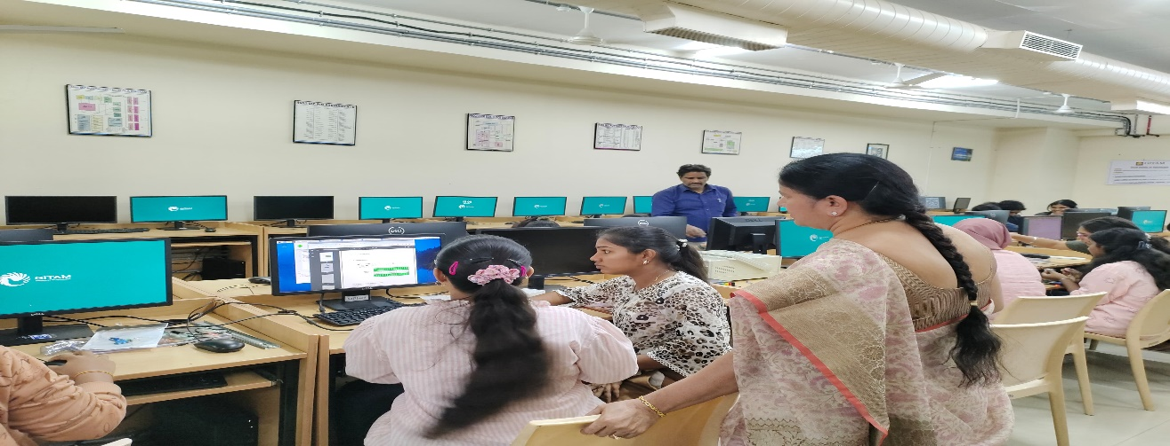

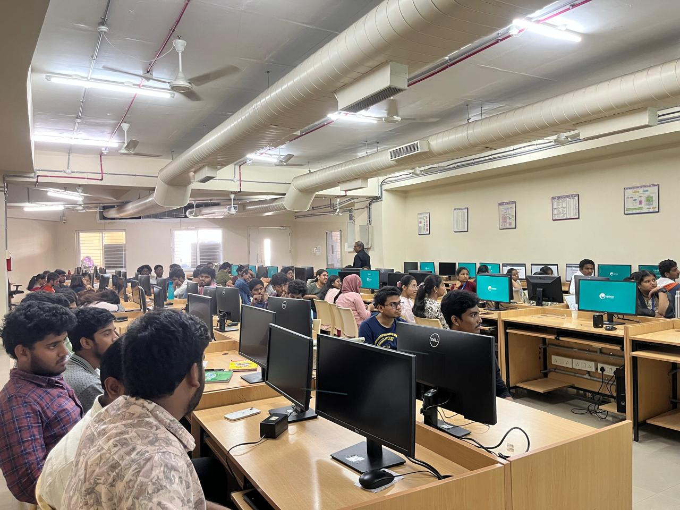

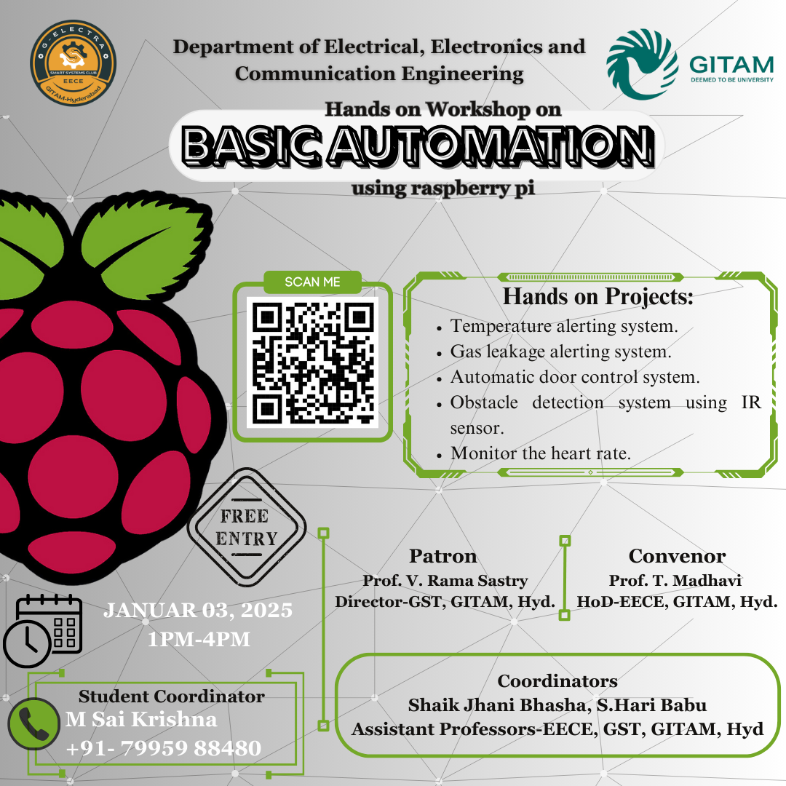

**2)The Department of EECE has conducted 3-day FDP on “EV Technologies3-day FDP on “EV Technologies: Development’s and challenges” (22 – 24 January 2025).:**

The Department of EECE has conducted 3-day FDP on “EV Technologies3-day FDP on “EV Technologies: Development’s and challenges Development’s and challenges” from 22-24 January 2025. Eminent resource people from IIT (IIT Gandhinagar, IIT Hyderabad) and Industry (National Instruments, TATA Elexi, Siemen’s) delivered the sessions

The First session of FDP started with the presentation of Dr. K. Ragavan from IIT Gandhinagar, the session covered topics of Introduction to EV technology and components, Motors Suitable for EV Applications, Control of BLDC and PMSM for Electric Vehicle Applications. The second session was given by a resource person from National Instruments and covered topics of Challenges in EV and possible research areas, How National Instruments can help to tackle the EV challenges.

The second day morning session started with the presentation of Dr. Venkatesham from IIT Hyderabad, and covered topics related to Types of Electric Vehicles, Electric vehicle modelling, Vehicle dynamics and power train mechanism. Some of the other topics covered in the subsequent sessions are EV Technologies: Developments and Challenges, Power quality, vehicle to grid and grid to vehicle connection, Battery management system (charging and discharging), EV Motor Control Modelling using MATLAB, Model-Based Design for Electric Vehicle, Component sizing and design control algorithm, AC and DC Electric Vehicle charging protocol, Real time implementation.

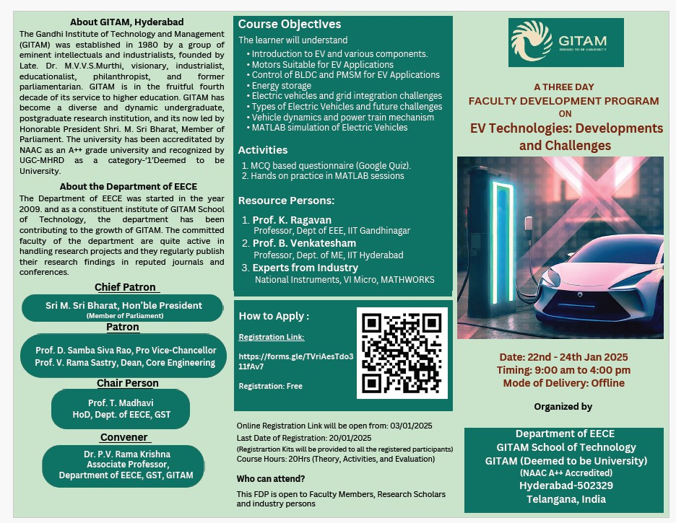

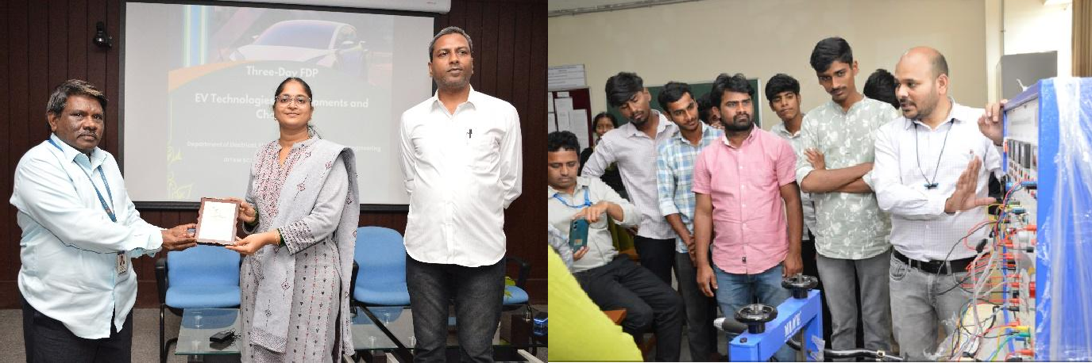

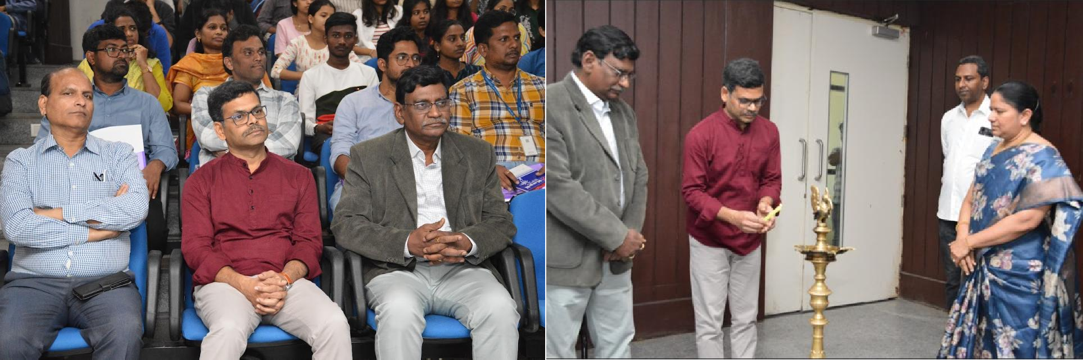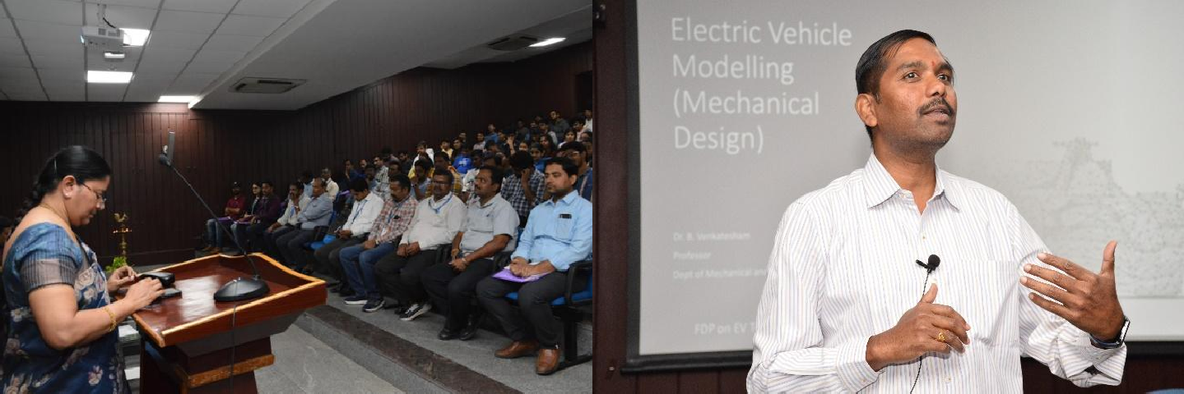

# 3)Havana Tech Fest 2025:

**DATE: 27 AND 28 FEBRUARY 2025**

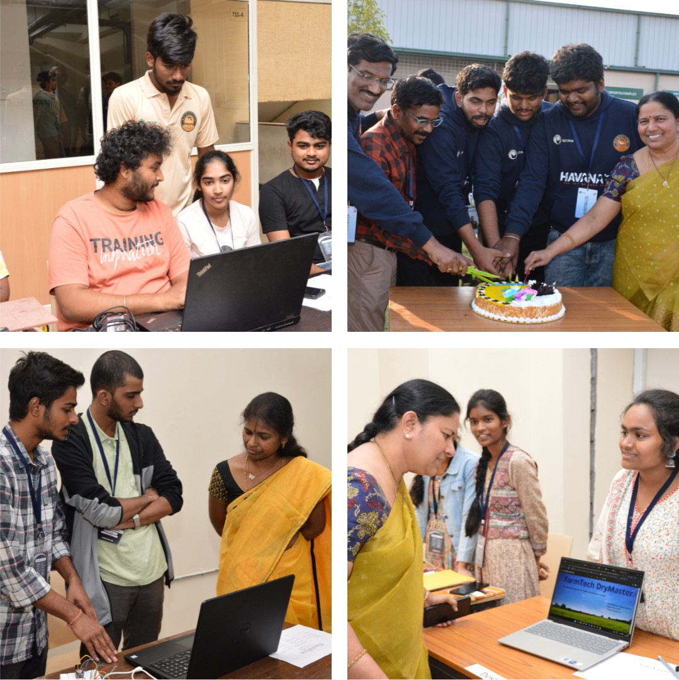**HAVANA Tech Fest 2025**, a national-level inter-collegiate technical fest hosted by **GITAM Deemed to be University, Hyderabad**, in collaboration with **G-Electra (Smart Systems Club)**, stood as a testament to the **convergence of innovation, technology, and collaboration**. Held under the esteemed presence of **Chief Guest Dr. G. Rameshwar Rao**, this two-day extravaganza unfolded with a grand inauguration ceremony, setting the stage for an immersive journey into the cutting-edge realms of technology. The festival brought together **students, faculty, industry professionals, and innovators**, fostering a dynamic ecosystem of learning, networking, and competition.

# Introduction:

In a world driven by innovation, **HAVANA Tech Fest 2025** emerged as a beacon, drawing together **the brightest minds, industry leaders, and technology enthusiasts**. The festival provided a **unique platform for the exchange of ideas, knowledge, and experiences**, transcending conventional boundaries and inspiring the next generation of engineers and innovators.

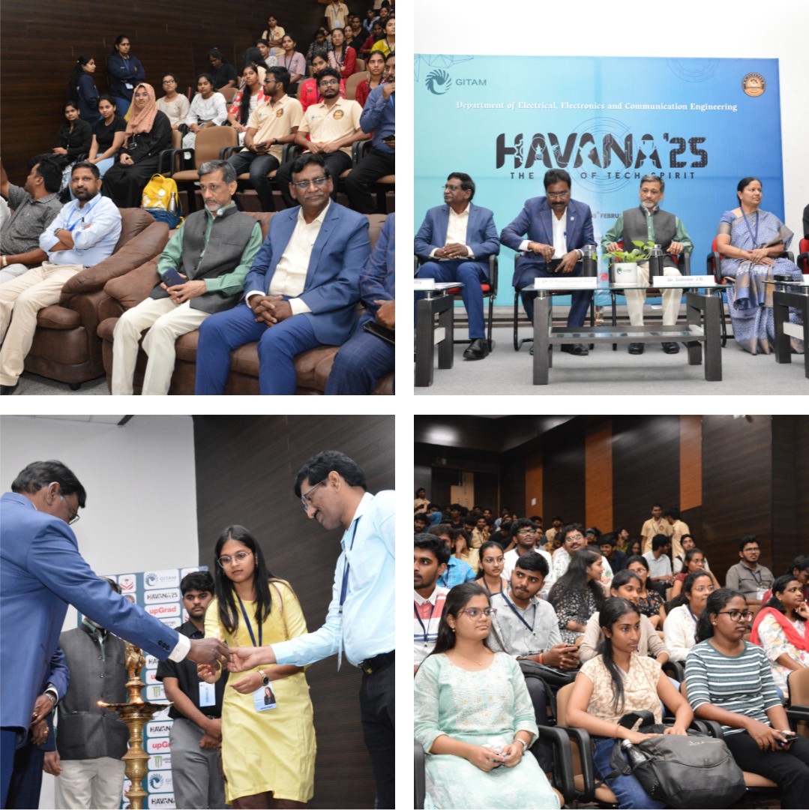

# Key Insights by Chief Guest – Dr. G. Rameshwar Rao:

* Emphasized the **importance of adaptability** in the ever-evolving technological landscape.
* Highlighted the significance of **practical learning and hands-on applications** in shaping future engineers.
* Stressed the role of **problem-solving and innovation** in addressing global technological challenges.
* Encouraged students to **think beyond geographical boundaries**, leveraging global opportunities in tech-driven industries.

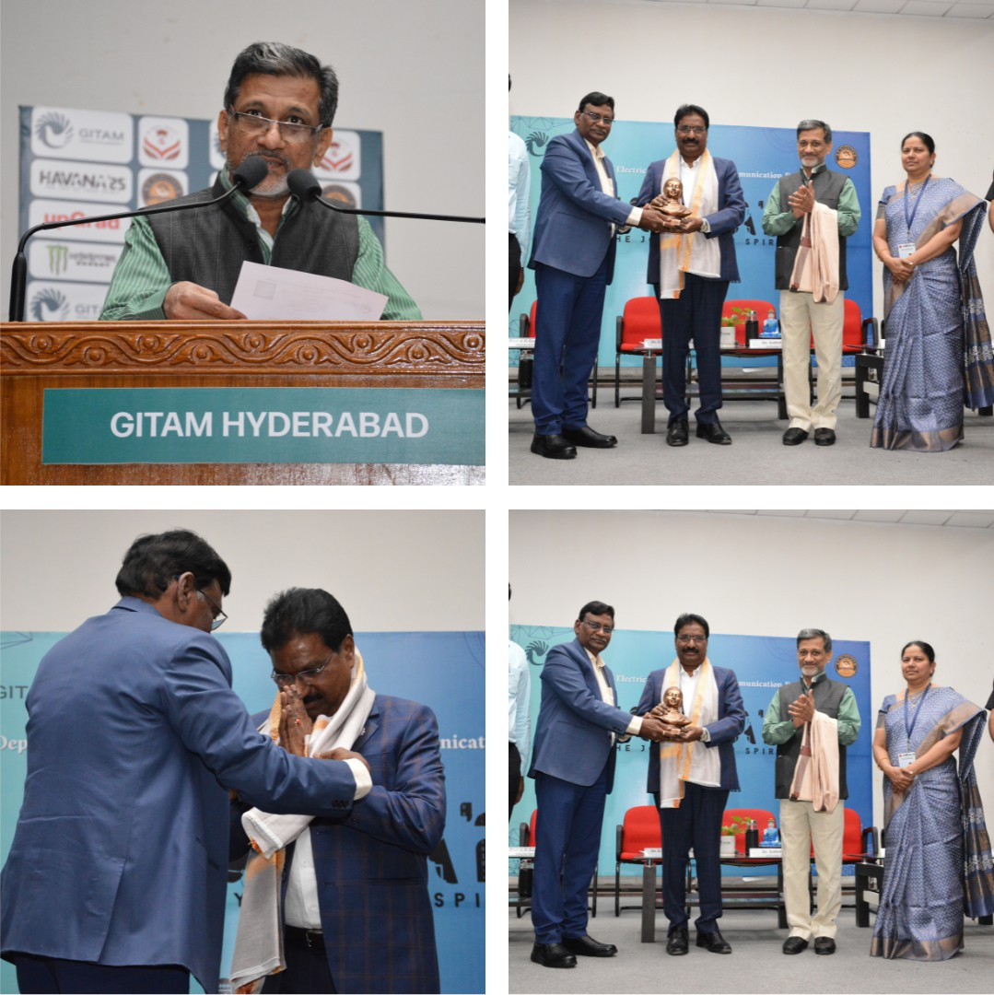

# Day 1 Highlights:

The inaugural day witnessed a **kaleidoscope of events**, each adding a unique hue to the fest's vibrant canvas. Competitions across **robotics, programming, aerodynamics, and strategy-based games** created an electrifying atmosphere, pushing participants to display **technical prowess and innovation**. Key events included:

* **TurboTRACK** – A high-speed challenge testing the precision and design of robotic models.
* **GripX** – A gripping contest where teams showcased robotic gripping mechanisms in real-world applications.
* **Striker League** – A dynamic robotic soccer competition, testing control, speed, and agility.
* **Knockout** – A battle of resilience where bots competed in an elimination-style showdown.
* **Track It** – A line-following robot competition evaluating navigation and efficiency.
* **AeroMaX** – A high-speed drone racing event showcasing aerodynamics and piloting skills.
* **Splash Rush** – A water-based robotics challenge integrating **engineering principles with real-world aquatic solutions**.
* **HackEra** – The ultimate **24-hour hackathon**, where teams delved into an **intense coding marathon**, developing **innovative solutions** to contemporary technological challenges.

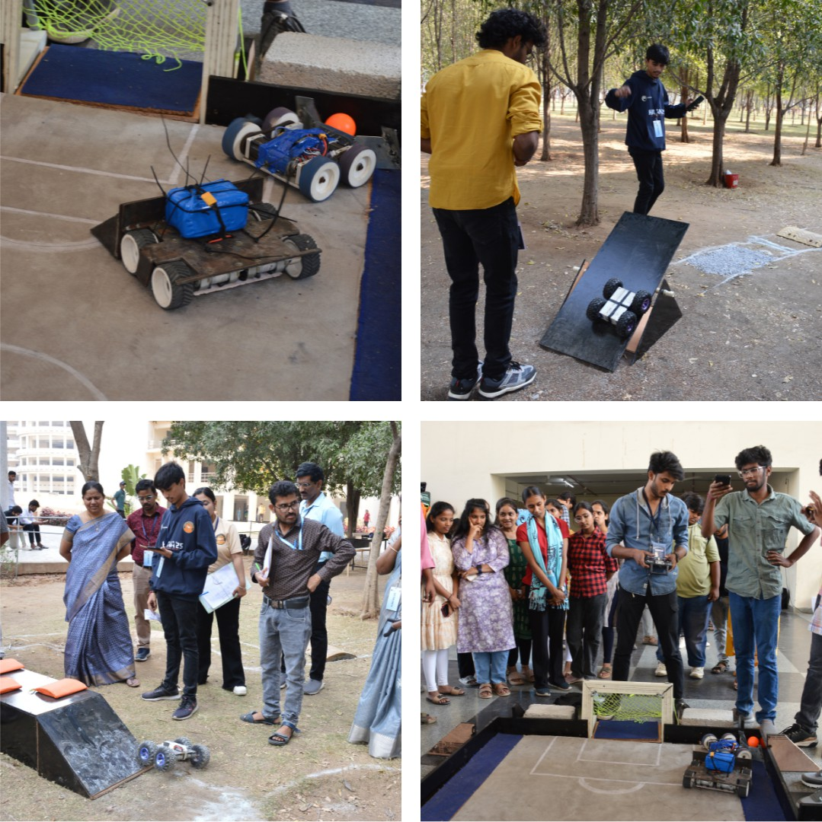

# Day 2 Highlights:

As the sun dawned on the second day, intellectual discussions and **entrepreneurial innovation** took center stage. The day featured **prototype exhibitions, pitch competitions, and coding battles**, enabling students to **demonstrate creativity, technical acumen, and business strategies**. Events included:

* **Protoverse** – A showcase of **prototype projects**, bringing cutting-edge technological solutions to the forefront.
* **devBattle** – A rapid-fire coding contest testing developers' agility in problem-solving.
* **Replica** – A challenge where participants designed and replicated real-world engineering models with precision.
* **InkSpire** – A **paper presentation** competition where students showcased their research and technical insights on emerging technologies.
* **Post a Pitch** – A **poster presentation** event that allowed participants to visually represent their innovative ideas and research findings to experts and peers.

The **grand finale of HackEra** saw teams unveiling their innovative solutions, developed through sleepless nights of coding and problem-solving.

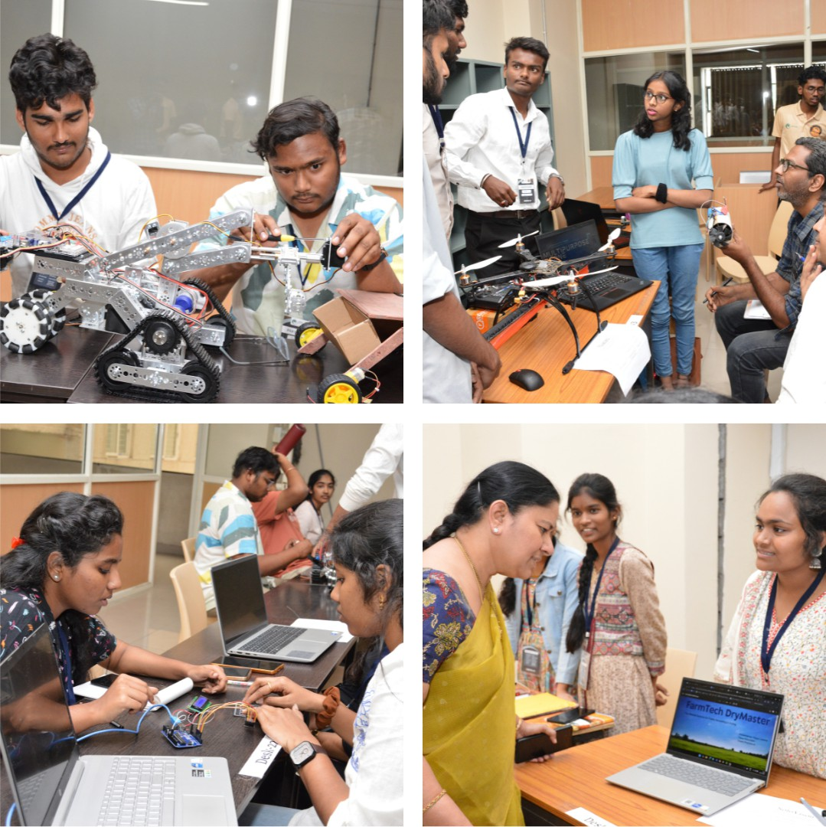

**4)PHYTEC Embedded workshop on emerging IOT trends and innovations**

PHYTEC Embedded is a global leader in embedded systems solutions, renowned for its expertise in designing and manufacturing high-quality System-on-Modules (SOMs), Single-Board Computers (SBCs), and custom embedded electronics tailored for industrial applications. Established in Mainz, Germany in 1985, PHYTEC has steadily expanded its operations with subsidiaries in the USA, France, China, and India, becoming a trusted partner for original equipment manufacturers (OEMs) worldwide.

PHYTEC’s core business revolves around providing modular embedded hardware platforms that help companies accelerate their product development, reduce engineering risks, and achieve faster time-to-market. Its SOM portfolio spans across advanced processors from ARM Cortex-A and Cortex-M series to x86 architectures, sourced from leading semiconductor vendors such as NXP, Texas Instruments, STMicroelectronics, and Renesas. By offering production-ready hardware backed by long-term availability, PHYTEC enables customers to focus on their application-specific innovation rather than low-level hardware complexities.

In addition to hardware, PHYTEC delivers robust software support, offering Linux, Android, Windows IoT, and RTOS BSPs (Board Support Packages), complemented by comprehensive tools for bootloader configuration, device tree customization, and peripheral drivers. Their engineering teams also provide customized software integration, enabling seamless transitions from prototype to mass production.

PHYTEC is distinct for its complete end-to-end approach. Beyond off-the-shelf products, it offers tailored hardware design services, helping customers develop carrier boards and custom form factors that precisely fit their application requirements. This design flexibility is backed by PHYTEC’s in-house production facilities, which include state-of-the-art surface mount technology (SMT) lines, automated optical inspection, X-ray verification, and rigorous quality assurance processes. This vertical integration ensures high reliability and traceability across all production stages, supporting industries with stringent regulatory needs, such as medical devices, automotive electronics, energy systems, industrial automation, and transportation.

PHYTEC also emphasizes lifecycle management, offering extensive product longevity guarantees, change management notifications, and design revalidation services to help customers maintain regulatory compliance and mitigate obsolescence risks. These services are critical for industrial customers whose product lifespans often exceed a decade.

PHYTEC INDIA, established in Bengaluru, serves as a major R\&D and customer support hub for the Asia-Pacific region. It plays a pivotal role in hardware design, software development, and localized support, ensuring that customers in India and neighboring countries receive timely engineering assistance and scalable solutions tailored to regional requirements.

A notable strength of PHYTEC is its commitment to continuous innovation. The company actively invests in emerging technologies, including embedded vision, artificial intelligence on the edge, and Industrial IoT (IIoT). It provides evaluation kits and reference designs that enable developers to quickly prototype smart applications involving machine learning and advanced sensor integration.

With a global workforce of over 400 professionals, PHYTEC maintains a collaborative engineering culture that blends German precision with local expertise across its branches. Its customer-centric philosophy is underpinned by decades of experience in embedded markets, making PHYTEC a preferred partner for businesses seeking dependable, scalable, and future-proof embedded solutions.

In summary, PHYTEC Embedded stands out as a comprehensive embedded systems provider, offering a unique combination of modular hardware platforms, software stacks, custom design services, and manufacturing capabilities. By addressing the full lifecycle needs of embedded product development, PHYTEC empowers its customers to bring innovative, high-performance solutions to market efficiently and reliably.

**---**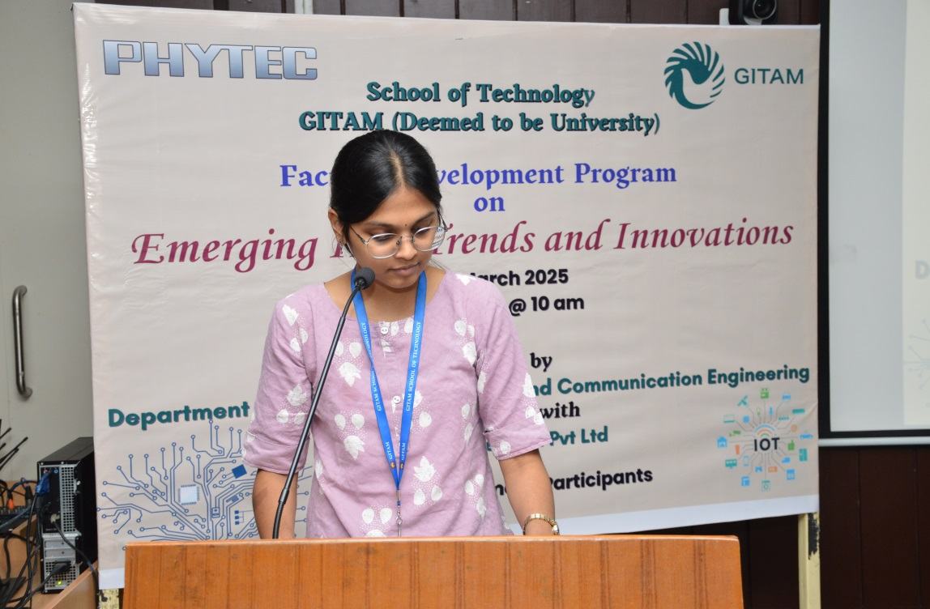

**5) Title of the Workshop: Six -Day Faculty Upgradation Programme (FUP) - 30 Hours**

**Theme:** Embedded Systems Programming on embedded Linux with Industry 4.0 Applications

**Organized by:GITAM University, Hyderabad Campus**

**Duration & Venue**

* **Dates:** 16-06-2025 to 23-06-2025 (6 days, 30 hours)
* **Venue:** GITAM Hyderabad Campus
* **Objectives of the Workshop**

The primary objectives of this Faculty Upgradation Programme were:

* To familiarize participants with Linux fundamentals and embedded Linux programming.
* To impart practical skills in hardware interfacing and sensor programming on embedded Linux platforms.
* To provide exposure to advanced topics such as multi-protocol gateway development and smart energy monitoring aligned with Industry 4.0.
* To enable faculty to integrate modern embedded systems and IoT concepts into academic curriculum and labs.

**Workshop Schedule & Highlights**

**Day 1: 16-06-2025**

* **09:00 – 12:00**  
  *Module-1: Introduction to Linux Basics & Programming*  
  Covered shell commands, file systems, and fundamental programming constructs in Linux.
* **14:00 – 17:00**  
  *Module-1: Hands-on Linux Basics & Programming*  
  Practical sessions on writing and executing basic programs and shell scripts.

**Day 2: 17-06-2025**

* **09:00 – 12:00**  
  *Module-2: Introduction to eLinux Porting*  
  Discussed cross-compilation, kernel configuration, and porting concepts.
* **14:00 – 17:00**  
  *Module-2: Hands-on eLinux Porting*  
  Hands-on practice on porting applications onto embedded Linux boards.

**Day 3: 18-06-2025**

* **09:00 – 12:00**  
  *Module-3: Introduction to HW Interface & Sensor Programming in eLinux*  
  Explained interfacing sensors and actuators with embedded Linux.
* **14:00 – 17:00**  
  *Module-3: Hands-on HW Interface & Sensor Programming*  
  Implemented sensor interfacing experiments on hardware boards.

**Day 4: 19-06-2025**

* **09:00 – 12:00**  
  *Module-4: Introduction to Advanced Sensor Interface Programming*  
  Covered multi-sensor integration and data acquisition techniques.
* **14:00 – 17:00**  
  *Module-4: Hands-on Advanced Sensor Programming*  
  Developed programs for simultaneous sensor data acquisition and processing.

**Day 5: 20-06-2025**

* **09:00 – 12:00**  
  *Module-5: Demonstration of Hands-on Project – Industry 4.0 Multi-Protocol Gateway Development*  
  Demonstrated gateway systems that integrate multiple industrial communication protocols.
* **14:00 – 17:00**  
  *Module-5: Demonstration of Hands-on Project – Smart Energy Meter and Energy Monitoring*  
  Showcased smart energy meter implementation with live monitoring dashboards.
* Day 6 23-06-2025

Module_6: *Demonstration of Hands-on Projects*

**Key Learnings & Outcomes**

* Gained practical exposure to Linux and embedded Linux programming workflows.
* Understood hardware-software co-design principles in sensor interfacing.
* Learned about multi-protocol gateways crucial for Industry 4.0 applications.
* Acquired insights into building energy monitoring solutions which can be proposed as student projects.
* Identified opportunities to modernize laboratory experiments in line with current industry practices.

**Suggestions for Future Workshops**

* Could include sessions on machine learning applications on embedded platforms.
* A small capstone project to be implemented by participants would enhance learning retention.

**6)AI-ML Introductory Workshop for Core engineering departments.**

**Organized by**

**School of Technology, Hyderabad**  
**Department of Computer Science and Engineering**

**Dates:** June 30th – July 1st, 2025

**Workshop Agenda**

**Day 1: Foundations & Domain Relevance**

| **Session** | **Title** | **Time Slot** | **Resource Person** |
| --- | --- | --- | --- |
| 1 | AI & ML: Foundations, Relevance and Integration in Engineering | 9:00 – 10:00 a.m | Dr. S. Ramakrishna |
| 2 | Data Visualization | 10:00 – 12:00 p.m | Dr. Mahaboob Basha Shaik |
| 3 | Setting up Python & Jupyter Notebook | 2:00 – 3:00 p.m | Dr. Sreedhar |

**Day 2: Diving Deeper & Applications**

| **Session** | **Title** | **Time Slot** | **Resource Person** |
| --- | --- | --- | --- |
| 1 | CNN for Image Datasets | 9:00 – 11:00 a.m | Dr. Sireesha V |
| 2 | Convolutional Neural Networks for Image Classification: A Step-by-Step Guide | 11:00 – 12:00 p.m | Dr. Rajib Debnath |
| 3 | Applications of Vision-Language Models in Core Engineering Domains | 2:00 – 3:00 p.m | Dr. Yaswanth G |

**Summary of Outcomes**

1. **Conceptual Understanding:**
   * Developed a strong foundation in the basic principles of Artificial Intelligence (AI) and Machine Learning (ML), particularly their relevance and integration within core engineering disciplines.
2. **Practical Exposure:**
   * Learned to set up Python environments and utilize Jupyter Notebooks, enabling hands-on experimentation with ML concepts.
   * Understood essential data visualization techniques to analyze engineering datasets effectively.
3. **Deep Learning Insights:**
   * Gained an introductory yet practical understanding of Convolutional Neural Networks (CNNs), including step-by-step methodologies for image classification tasks.
4. **Emerging Applications:**
   * Explored real-world applications of vision-language models and how these cutting-edge AI technologies can solve domain-specific problems in core engineering areas.
5. **Interdisciplinary Perspective:**
   * The workshop bridged computer science concepts with core engineering applications, equipping faculty members to adopt and promote AI-ML methods in their respective fields.

**Concluding Remarks**

The Phase II AI-ML Introductory Workshop was highly beneficial in strengthening the AI-ML knowledge base of faculty members from core engineering departments. It provided both theoretical insights and practical skills, laying the groundwork for incorporating AI-driven approaches into teaching, student projects, and future research initiatives.

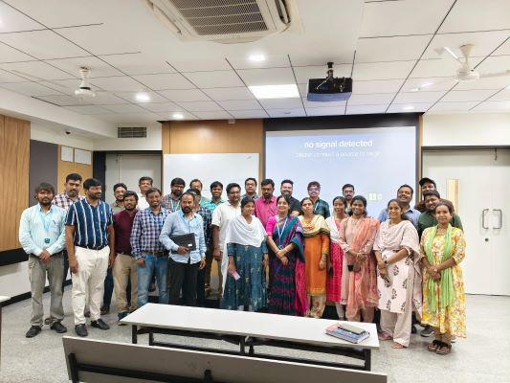

Photo of Al-ML workshop

7) Five Day Intensive Course Future Tech Fpga & 5G Antennas

DATES JUNE -23 27,2025

**Organized by**

**School of Technology, Hyderabad**  
**Department of Computer Science and Engineering**

The Five-day intensive course enabled participants to develop strong foundational knowledge in FPGA design and millimeter-wave antenna engineering. Participants gained practical experience with hardware programming using Verilog and applied this knowledge to real-time FPGA applications. Through hands-on sessions using ZedBoard and Pynq boards, learners successfully implemented and optimized digital circuits for high-speed data processing. The course enhanced participants' industry readiness by exposing them to real-world FPGA project workflows. In parallel, attendees mastered the principles of millimeter-wave antenna design using Advanced Design System (ADS) software. They acquired skills in simulating and optimizing antennas for cutting-edge 5G, radar, and satellite communication systems. Learners practiced layout design and EM simulation techniques to evaluate antenna performance. The course emphasized beamforming concepts and introduced phased array systems for directional communication. High-gain antenna design and optimization strategies were explored in detail to improve system efficiency. Collaborative lab exercises helped participants understand the challenges and solutions in both hardware and antenna domains. By the end of the course, learners demonstrated improved confidence and competence in applying theoretical knowledge to practical problems. Overall, the course successfully bridged the gap between academic learning and industry application in future communication technologies.

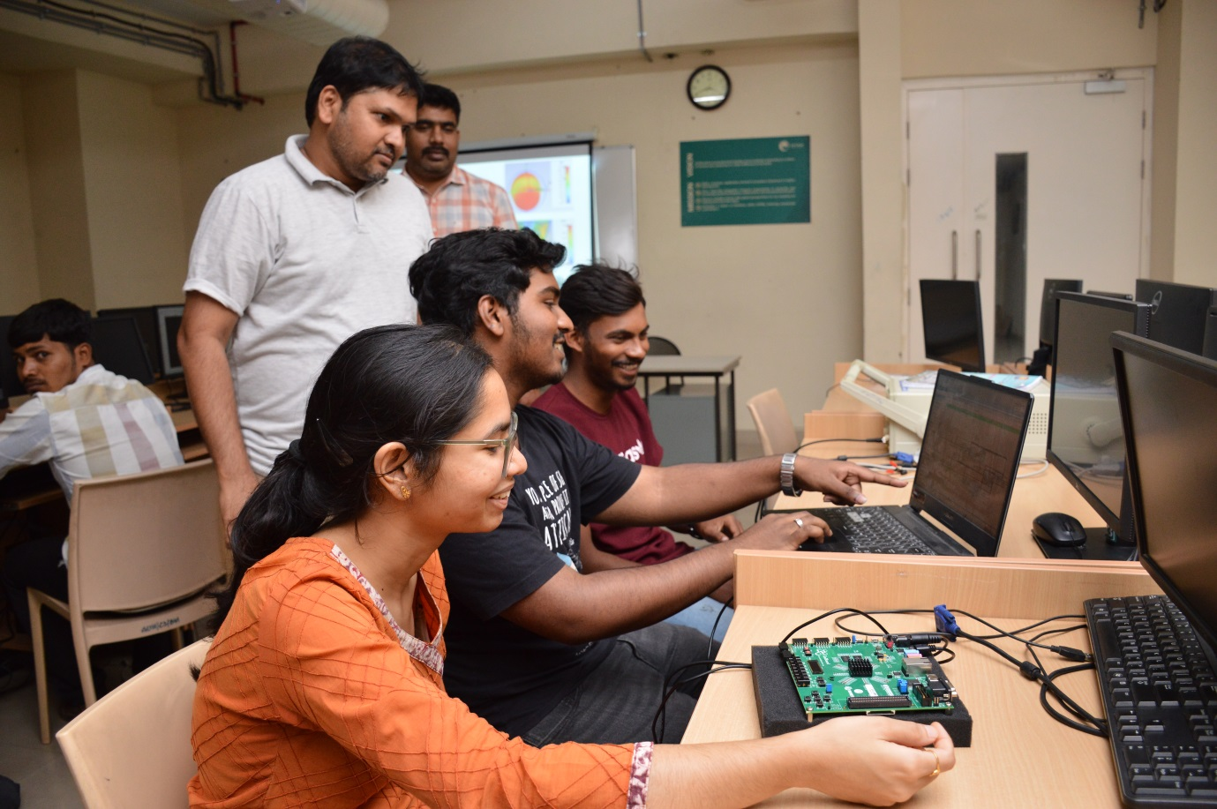

**8) The MoU between GITAM University, Hyderabad Campus and Phytech Embedded Pvt. Ltd.**

GITAM (Deemed to be University), Hyderabad Campus, entered into a Memorandum of Understanding (MoU) with **Phytec Embedded Pvt. Ltd.**, a leading embedded systems solutions provider, to foster industry-academia collaboration in the field of **Embedded Systems, IoT, AI, and Industry 4.0 applications**.

**Purpose and Objectives:**

* To bridge the gap between academic curriculum and industry requirements.
* To promote **joint research, training, and skill development** initiatives in embedded systems and related technologies.
* To establish **centers of excellence/labs** equipped with Phytec hardware for practical learning.
* To facilitate **internships and industrial visits** for students at Phytec’s facilities.
* To organize **workshops, guest lectures, and faculty development programs (FDPs)**.
* To assist in **curriculum design and development** aligned with industry needs.

**Key Areas of Collaboration:**

1. **Training & Workshops:**
   * Hands-on sessions on ARM Cortex, Linux-based embedded systems, IoT platforms, etc.
   * Participation in seminars and technical events.
2. **Student Engagement:**
   * Internship opportunities at Phytec.
   * Project guidance for final-year and capstone projects.
   * Campus recruitment drives.
3. **Faculty Empowerment:**
   * Faculty development programs (FDPs).
   * Research collaboration opportunities.
4. **Infrastructure Development:**
   * Support for setting up embedded and IoT labs with Phytec tools and boards.
   * Licensing of Phytec software and training materials.

**Expected Outcomes:**

* Enhanced student employability through exposure to **real-world embedded systems**.
* Collaborative research and prototype development.
* Industry-aligned teaching-learning practices.

Creation of a **sustainable ecosystem** for innovation and product development